## **Criterion B**

**Design Outline**

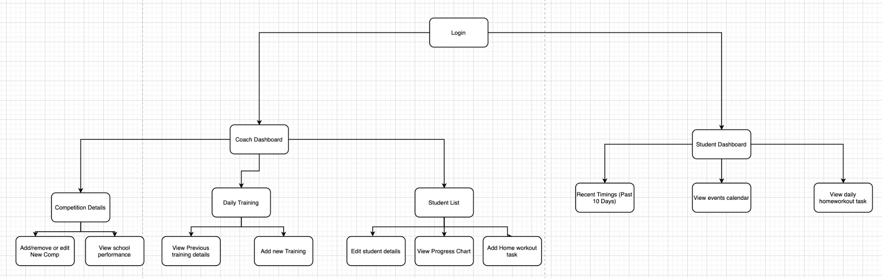

(Magnified view of the Coach module)

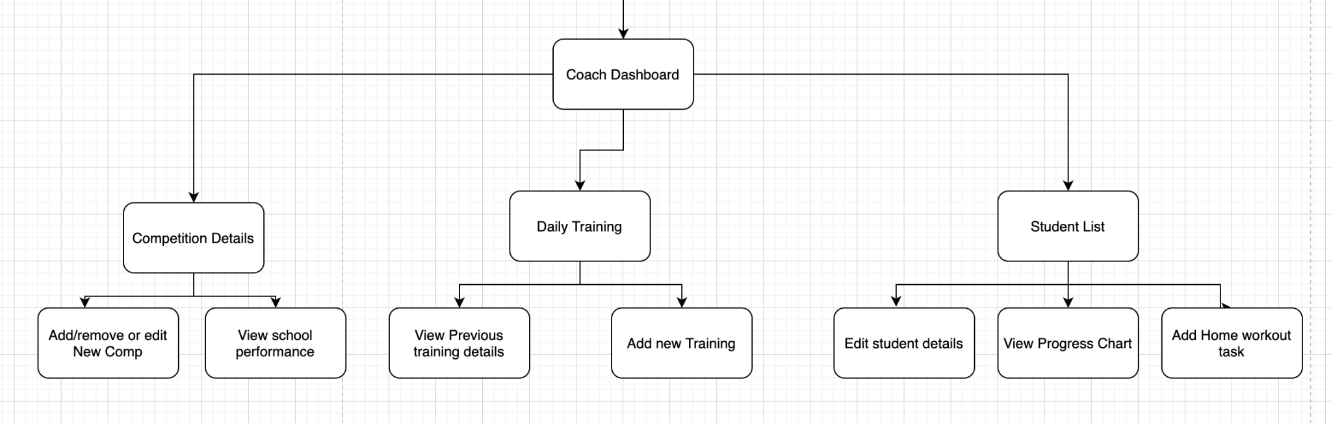

(Magnified view of the Student module)

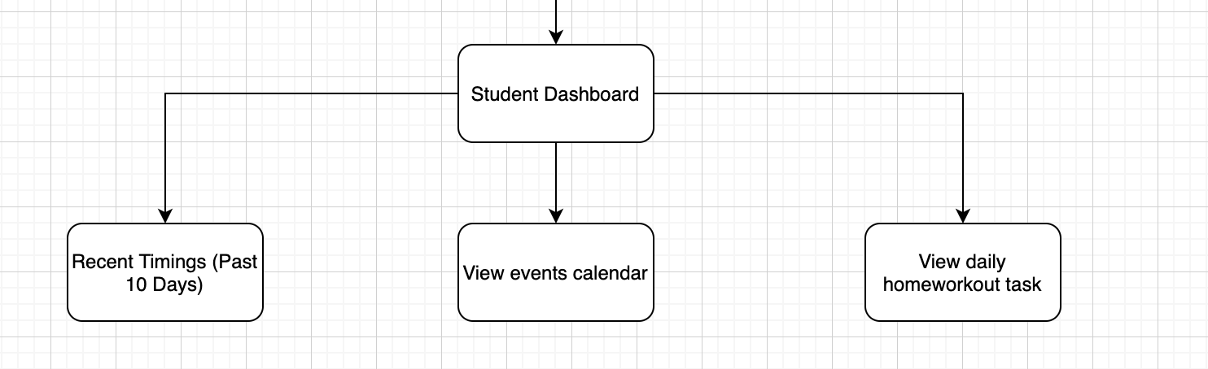

**Screen Layouts**

Login Screen

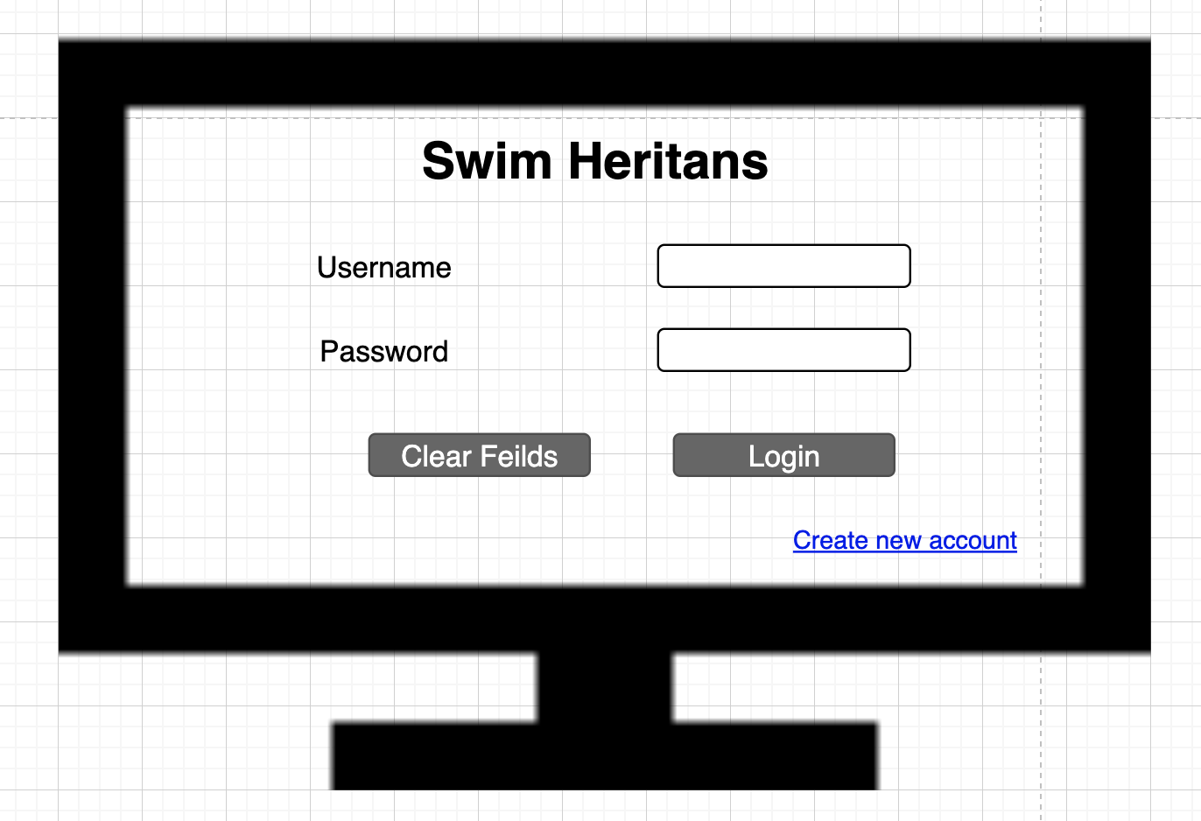

Student Dashboard

(Recent performance, View Home Workout Task)

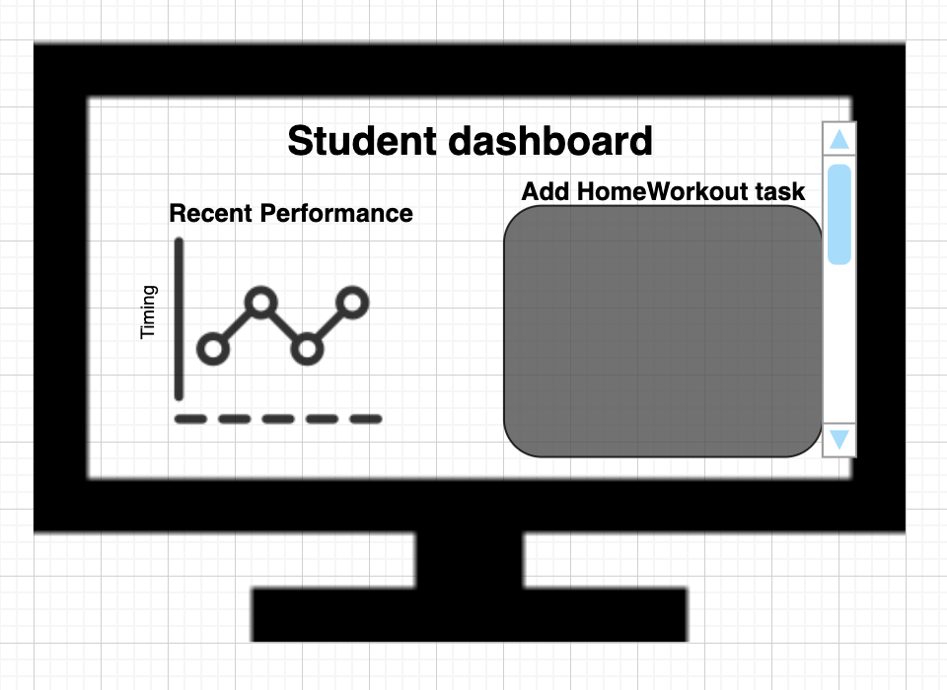

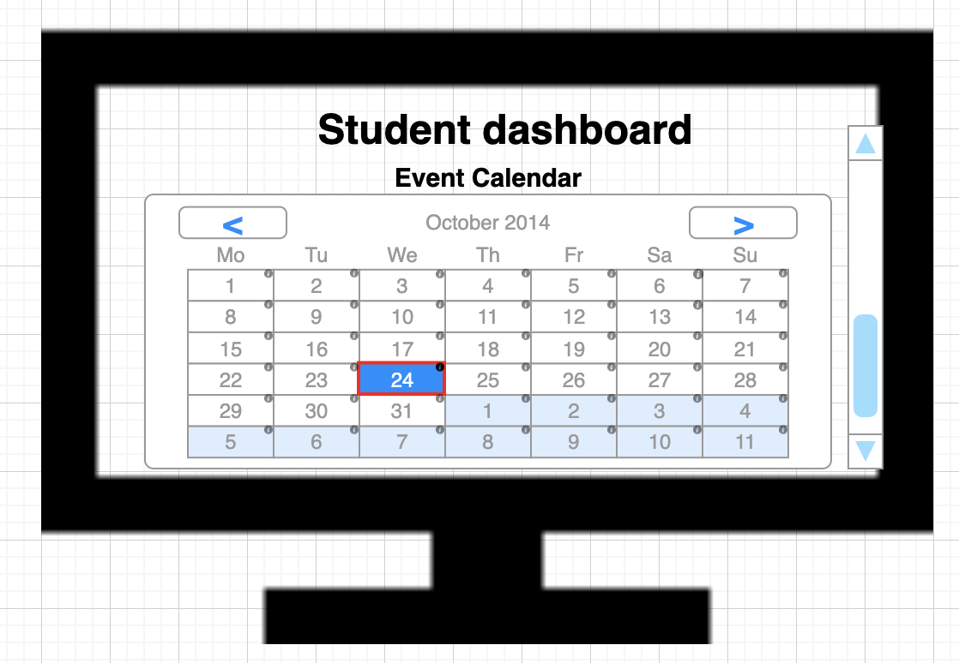

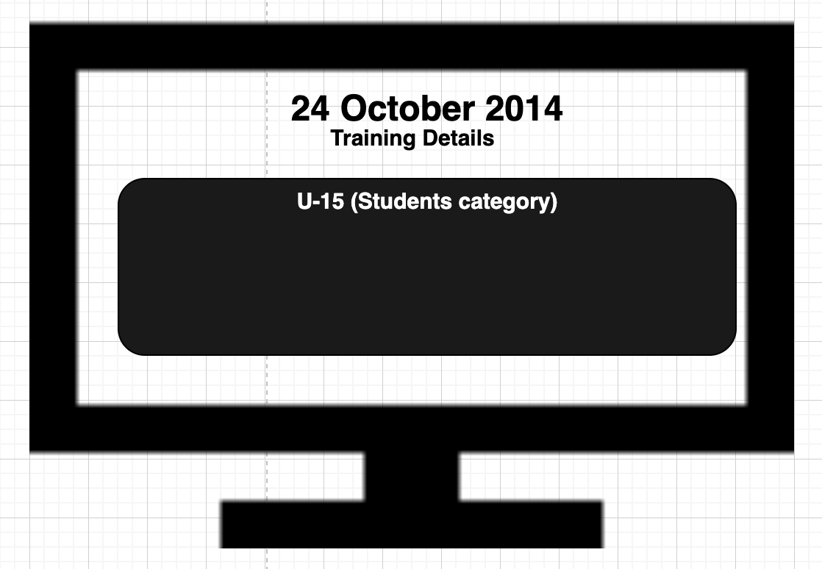

Coach Dashboard

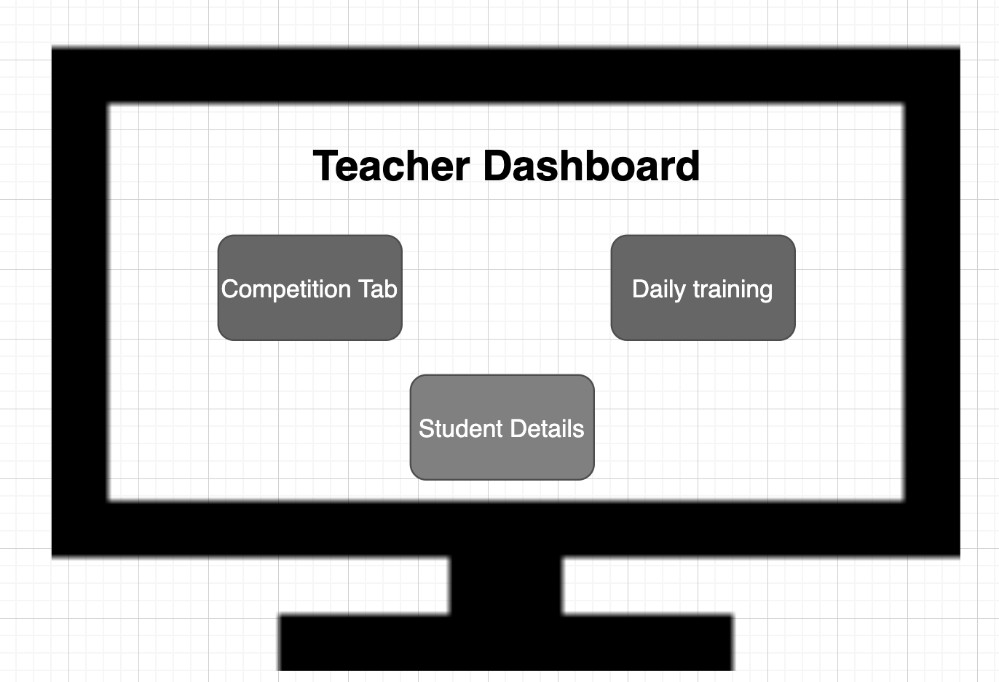

Competition Details  
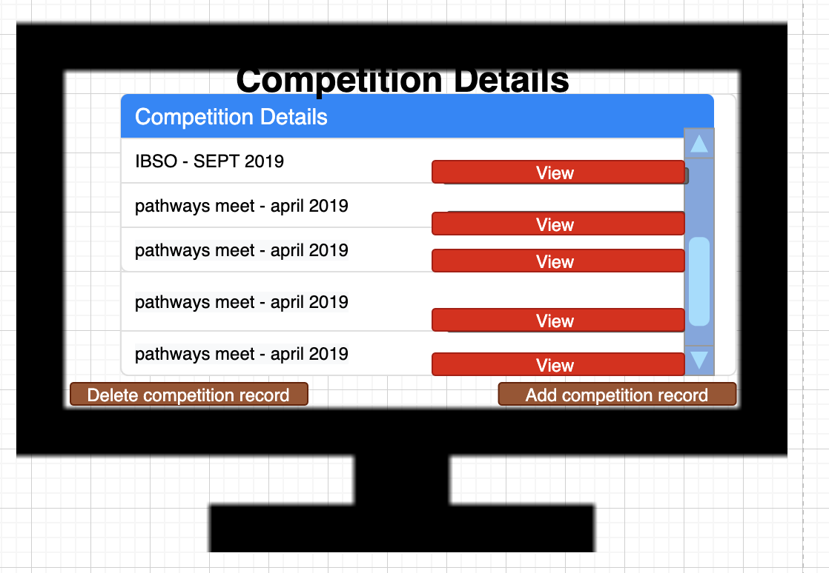

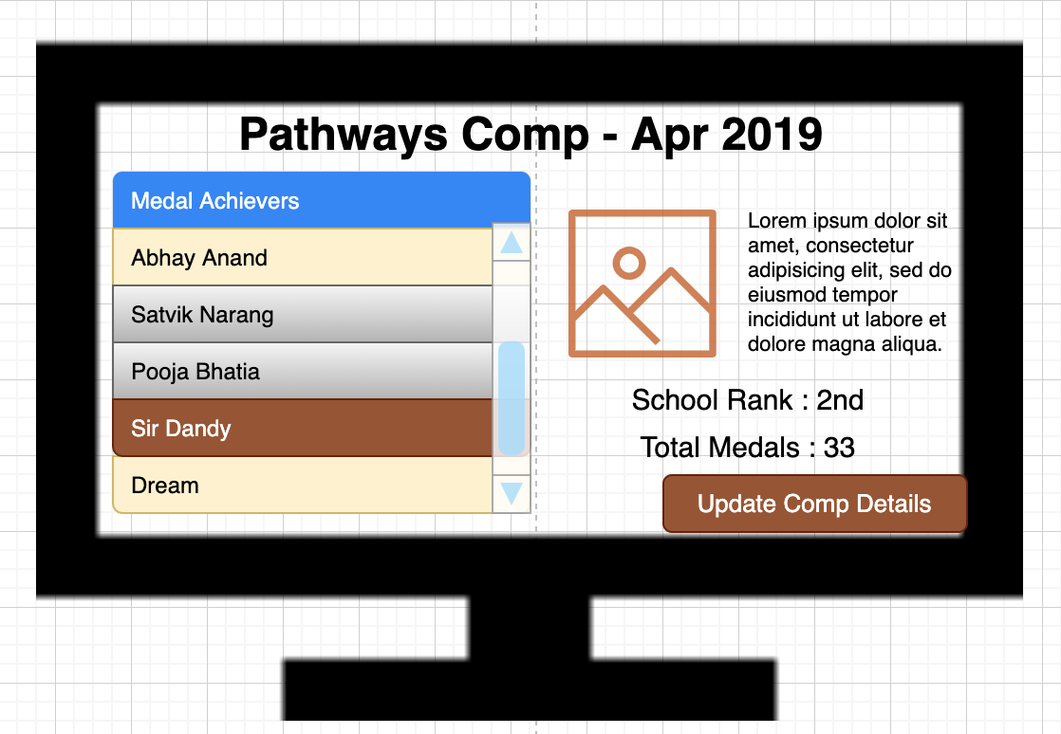  
  
Student Details  
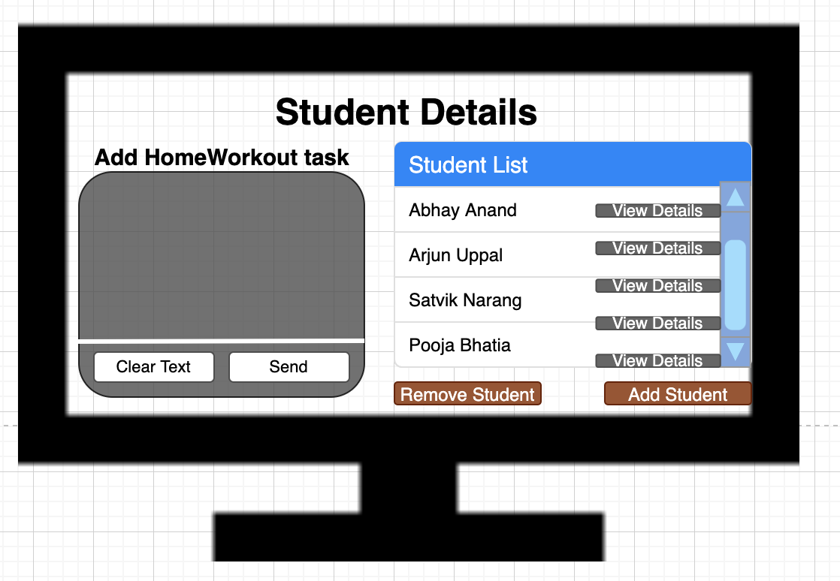  
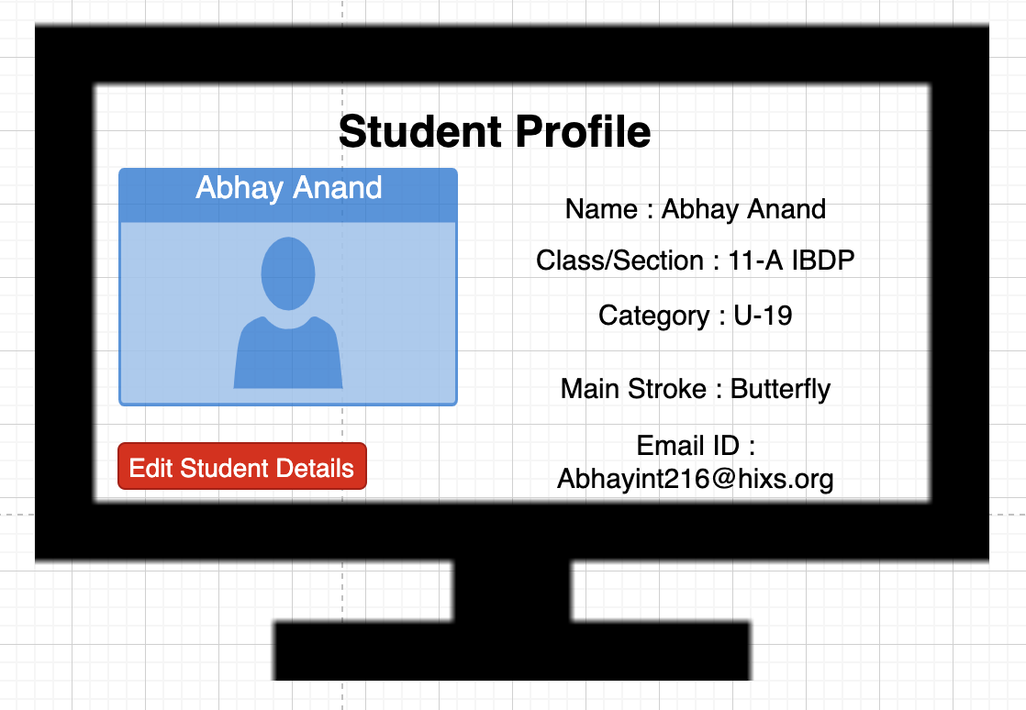

Daily Training  
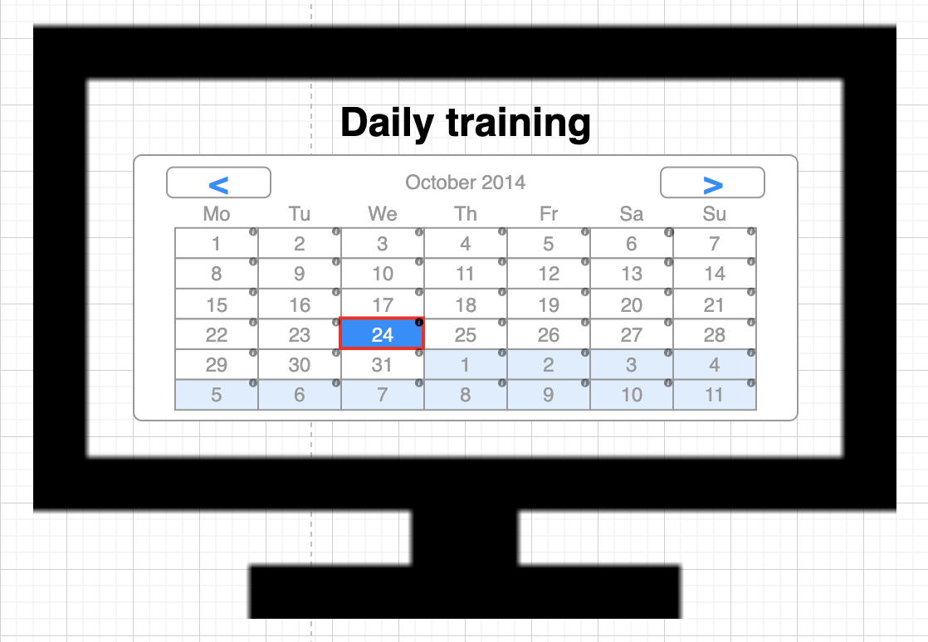  
  
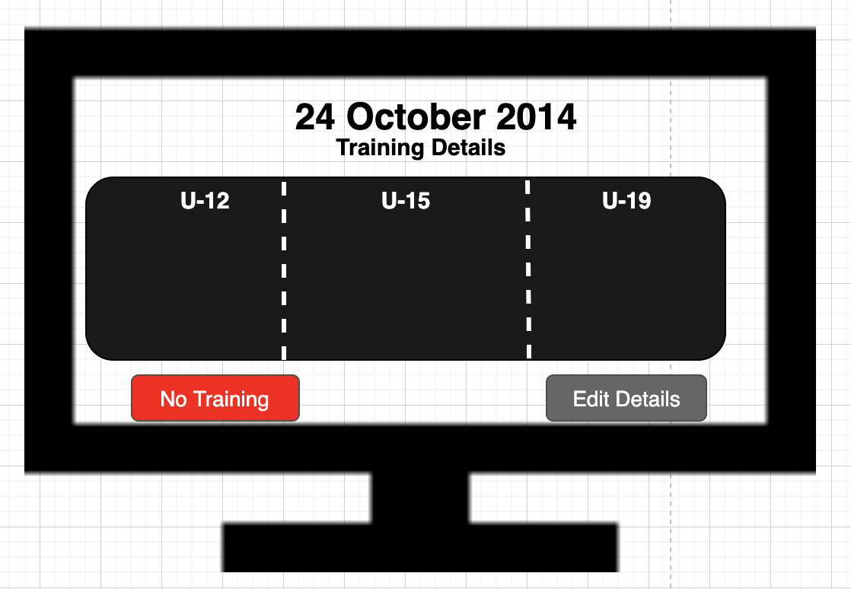

**Flowchart**

**Signup:  
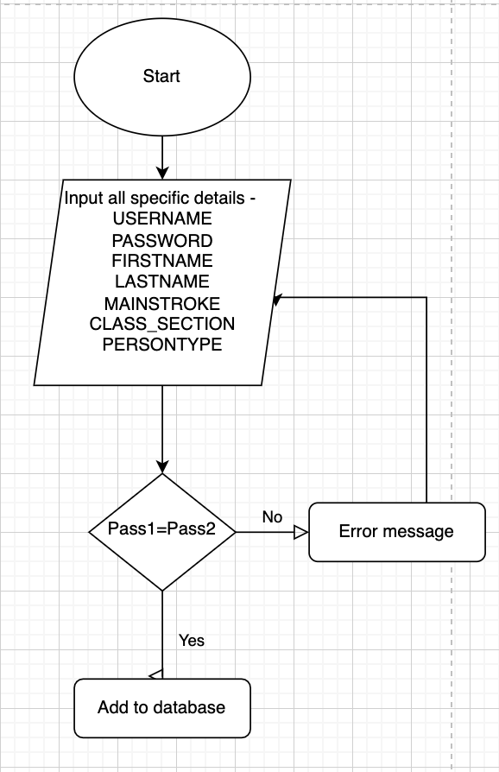  
Login:   
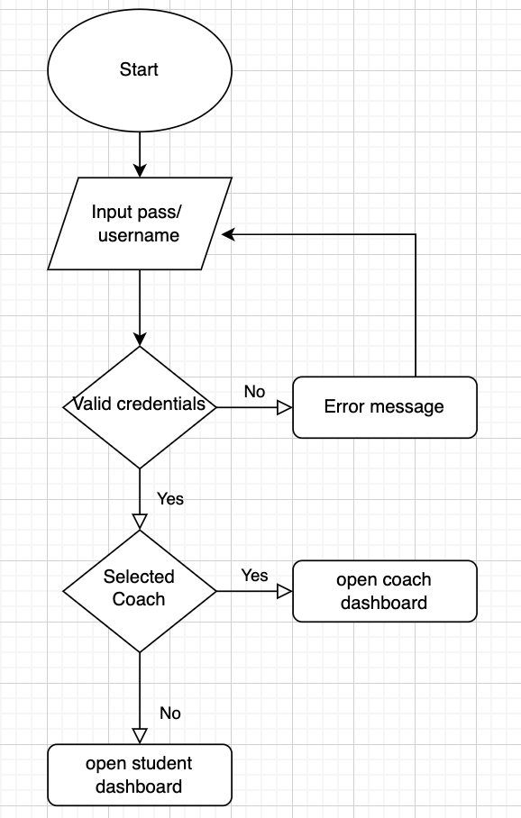**

**Student Dashboard:  
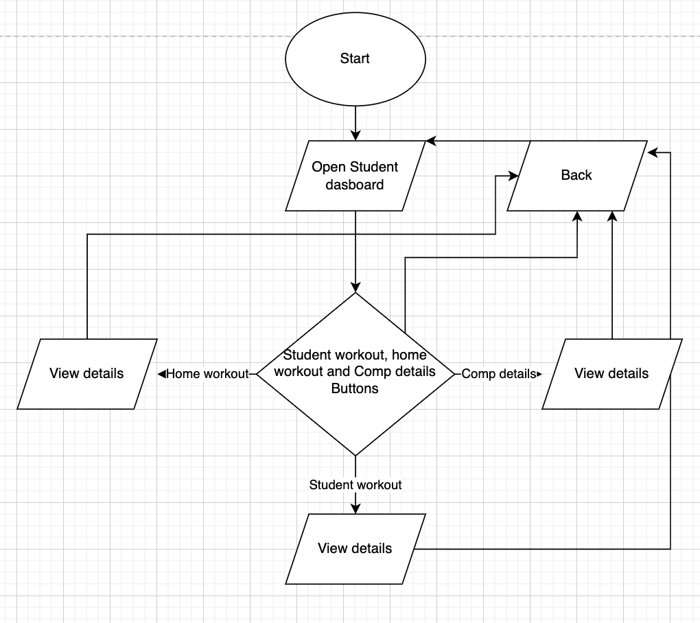**

**Coach Dashboard**

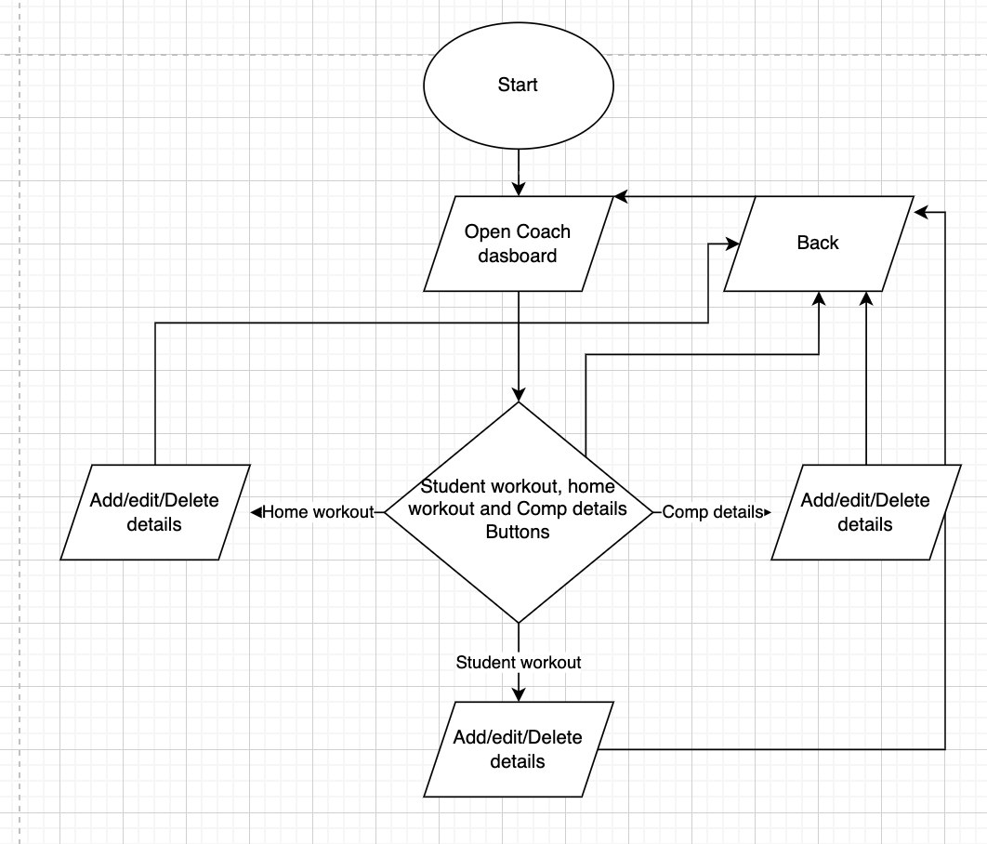

**Database Structure**

**Table Name: login**

**Description: This table stores login credentials for various user accounts.**

|  |  |  |
| --- | --- | --- |
| **Field Name** | **Field Type** | **Description** |
| USERNAME | VARCHAR(50) | STORES username |
| PASSWORD | VARCHAR(50) | STORES password |
| FIRSTNAME | VARCHAR(50) | STORES firstname |
| LASTNAME | VARCHAR(50) | STORES last name |
| MAINSTROKE | VARCHAR(50) | STORES main stroke |
| CLASS_SECTION | VARCHAR(50) | STORES class/section |
| PERSONTYPE | DROPBOX | STORES coach/ student account |

**Table Name: Competition Details**

**Description: This table will store details of all swimming competitions.**

|  |  |  |
| --- | --- | --- |
| **Field Name** | **Field Type** | **Description** |
| COMPID | VARCHAR(11) | STORES ID of a competition |
| COMPNAME | VARCHAR(100) | STORES name of a competition |
| COMDATE | datetime | STORES competition date |
| ACHIEVEMENTS | VARCHAR(50) | STORES achievements in medals |

**Table Name: Student Workout**

**Description: This table stores student details for all students who are part of the swimming team and their timing at specific events.**

|  |  |  |
| --- | --- | --- |
| **Field Name** | **Field Type** | **Description** |
| STUDENTNAME | text | STORES Student name |
| DATE | datetime | STORES Date when timing is recorded |
| TIMINGS | VARCHAR(300) | STORES stroke |
| CLASS_SECTION | VARCHAR(50) | STORES achievements in medals |

**Table Name: Homeworkout**

**Description:This table will store the daily plan of the coach for a particular training session**

|  |  |  |
| --- | --- | --- |
| **Field Name** | **Field Type** | **Description** |
| AGECATEGORY | VARCHAR(300) | STORES age |
| DATE | datetime | STORES date of training |
| TRAININGDETAIL | VARCHAR(300) | STORES training during 1hr morning practice |
| HOMEWORKOUT | VARCHAR(300) | STORES the homeworkout task sent by teacher on certain day |

**Test Plan**

|  |  |
| --- | --- |
| Action to be tested | Test Method |
| 1. Build a GUI based desktop application | Check if all inputs and outputs are GUI based. Try different inputs to verify the functionality of the product and ensure that there are no run time errors. Ensure navigation in the program in smooth. |
| 2. Creation of a database tables that stores all the students and coaches record | Check if data entered is stored in a database |
| 3. Create a login form for Students and Coaches and register them with details | Make sure the user can access information only based on their login account. Ensure that a user’s login restricts their actions. |
| 4. Feature to add and delete new students to the swim team list achievers for a certain competition | Check if coach can edit/ add or delete a students information to the database |
| 5. Create Teacher Dashboard with Competition Details, Student Details, and Daily Training options. | Check to see if the three buttons allow for teachers logged in to see three different screens with different functional pages (Competition Details, Student Details, and daily training) |
| 6. Add and delete competitions detail with achievements | Add/delete/edit competition information from the database through interface |
| 7. View swimming team’s performance based on competitions and medals won by team | view competition information from the database through interface table |
| 8. Features to add training details with age category and home work out details | Add/delete/edit training details of students through the interface |
| 9. Feature to edit Timings or delete them during competitions | Add/delete/edit timings of students in competitions/morning practise through interface |
| 10.Allow teachers to use the home-workout feature to add workout plans for students and Students can view | Add/delete/edit home workout tasks for the students through interface |
| 11. ​​Create student dashboard with training calendar, record recent timings, and view homework task. | Check to see if the three buttons allow for teachers logged in to see three different screens with different functional pages (Competition Details, Student Details, and daily training) |
| 12. Feature to View competition details, student achievements and timings | view home details of events/competitions the students of heritage participated in through interface table and view button. |
| 13. Features to view progress bar, student details with workout tasks with class details. | view home details of events/competitions the students of heritage participated in through interface table and view button. |
| 14. Student portfolio with recent timings for the known participating competitions and the total achievements and training details. | view details the students’ performance during daily practice and competition through interface table and view button. |
| 15. User friendly interface to display all these features in menus in a single home screen with logo of swimming app on all screens | Have a common color scheme with buttons that allow for the users to easily move between the interfaces based on the type of account. |